ENGINEERING PORTFOLIO
Jack Weir

MEng Engineering • NMITE • Hereford
Jack.harold.weir@gmail.com • 07398 813066

Project 01  Light-Triggered Soap Dispenser  Analogue & Digital Electronics |  | Project 02  Culvert Blockage Sensor System  Embedded Systems • IoT • CAD |  | Project 03  Portable Lifting Mechanism  Mechanical Design • SolidWorks • 3D Print

PROJECT 01
Light-Triggered Soap Dispenser
Analogue & Digital Electronics • E4012 Fundamentals of Analogue and Digital Circuits

Project Overview
Designed and built a fully automated soap dispenser that refills reusable containers — reducing single-use plastic and improving user experience. The system uses a Light Dependent Resistor (LDR) to detect when a container is placed in position, then triggers a timed pump cycle to dispense a precise and consistent volume of detergent.
The project was developed as part of the E4012 module and required designing two functional circuits — one analogue, one digital — which were then integrated into a single working system.

Module | E4012 — Fundamentals of Analogue and Digital Circuits
Type | Individual electronics design project
Supply voltage | 5V SELV (Safety Extra-Low Voltage)
Key outcome | Automated, consistent, hands-free soap dispensing

The Problem
Existing soap dispensers require manual operation and use single-use plastic cartridges. The client brief required a system that detects container presence automatically, dispenses a fixed volume every time, prevents overfilling, and provides clear user feedback — all while operating safely at low voltage.

How It Works

Analogue Stage — Detection
An LDR forms a voltage divider with a fixed 10 kΩ resistor. At 100 Lux — the trigger point — the LDR resistance equals the fixed resistor, producing exactly 2.5V at the comparator input. A 100 kΩ potentiometer is calibrated to the same reference voltage. When a container blocks the ambient light, the LDR voltage drops below the reference and the comparator output goes high, switching on a PNP transistor that powers the 555 timer.
- LDR + voltage divider: triggers at 100 Lux (2.5V output at threshold)
- Comparator (IC1): compares LDR voltage to potentiometer reference
- PNP transistor (Q2): isolates comparator signal from power rail to 555 timer

Analogue Stage — Timing
The 555 timer is configured in Astable mode, producing a continuous oscillation that acts as a clock signal. Resistor values were calculated to produce a 2-second high period and 0.79-second low period:
- R1 = 10 kΩ, R2 = 11.5 kΩ, C = 100 µF
- Tₕᵢᵧᵸ = 0.693 × (R1 + R2) × C = 2 seconds
- Tₗₒᵂ = 0.693 × R2 × C = 0.79 seconds
- N-channel MOSFET (Q1): boosts signal current to drive the pump motor

Digital Stage — Count & Control
The 555 clock signal feeds into an Octal Counter (IC5). After 4 pulses, the counter stops, cutting power to the motor. A 4-input OR gate (IC4a) detects any active counter output and runs the motor during counting. An AND gate (IC3a) combines the OR gate output with the comparator signal, ensuring the motor cannot run if the container has been removed mid-cycle. A status LED (D2) illuminates while the counter is active, giving the user clear feedback.
- Octal counter: counts 4 pulses then stops — controls dispensing volume
- OR gate: drives motor whenever any counter output is active
- AND gate: safety interlock — motor cannot run without container present
- LED indicator: on during fill cycle, off when complete

Boolean logic: F = E · (A OR B OR C OR D) — motor only runs if comparator is high AND counter is counting

Key Components
LDR (R3) | Light sensor — variable resistance triggers circuit when container placed
Comparator (IC1) | Compares LDR voltage to reference; outputs high/low signal
555 Timer (IC2) | Astable mode oscillator — generates clock pulses for counter
Octal Counter (IC5) | Counts 4 clock pulses then stops pump — ensures consistent fill
MOSFET (Q1) | Switches motor current from low-voltage logic signal
LED (D2) | Visual indicator — illuminates during fill cycle

Photo / Circuit Diagram
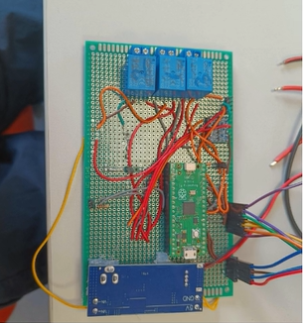
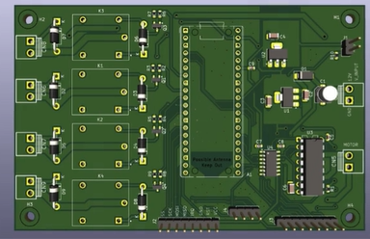

Results & Reflection
The circuit successfully detected container presence, dispensed a consistent fixed volume each cycle, and provided clear LED feedback. The AND gate interlock prevented the motor running after the container was removed mid-cycle, addressing a key safety requirement.
- Consistent dispensing volume achieved through timed counter logic
- 5V SELV operation ensures user safety around water and soap
- AND gate interlock adds hardware-level safety not reliant on software
- LED provides clear, intuitive feedback without requiring any instructions

This project developed my ability to read and apply datasheets, calculate timing components from first principles, and combine analogue and digital circuit techniques into a single integrated system.

PROJECT 02
Culvert Blockage Sensor System
Embedded Systems • IoT • CAD • Real-World Client Brief

Project Overview
Designed and built a low-cost autonomous monitoring system to detect blockages in railway culverts on behalf of Network Rail / Transport for Wales (TfW). The system uses two waterproof ultrasonic sensors and a Hall-effect flow sensor, processed by a Raspberry Pi Pico, to detect when a culvert may be blocked — and triggers an automated alert.
With approximately 30,000 culverts across the UK, undetected blockages can cause flooding, track damage, and road closures. This project was a response to a real client brief with a £50 component budget.

Client | Network Rail / Transport for Wales (TfW)
Budget | £50 for all sensors and components
Processor | Raspberry Pi Pico (edge computing)
Sensors | 2× JSN-SR04T ultrasonic + 1× YF-S201 Hall-effect flow sensor
Alert logic | 30 consecutive readings of high differential + low flow
Team size | 3 students

The Problem
Culvert blockages build up gradually before causing sudden flooding. Manual inspection is expensive and infrequent. The client needed a reliable, low-maintenance, weather-resistant system that could detect the early signs of a blockage and send an alert remotely — deployed across thousands of sites cost-effectively.

Solution Design

Sensor Selection
Six detection concepts were evaluated using a weighted decision matrix against criteria of cost, reliability, maintenance, and safety: camera, buoy + colour stripe, laser receiver, photo receptor, PVC pipe + float, and flow sensor. The PVC pipe concept was adapted to incorporate waterproof ultrasonic sensors, removing the mechanical failure risk of a float and the cost of cameras or laser systems.
- Ultrasonic sensors (JSN-SR04T): waterproof IP67, ±0.2cm accuracy, £4 each
- Flow sensor (YF-S201): inherently waterproof, counts turbine pulses (7.5 pulses = 1 L/min)
- Raspberry Pi Pico: low cost (£4), sufficient GPIO, runs MicroPython

Blockage Detection Logic
The Pico samples both ultrasonic sensors and the flow sensor every 0.5 seconds. If the water level inside the culvert is more than 10 cm lower than outside AND flow rate is low for 30 consecutive readings, the system flags a blockage. All threshold values are stored in a dedicated variables section in the code for easy field calibration without modifying the core logic.
Boolean condition: ALERT if (outer_level − inner_level > threshold) AND (flow_rate < min_flow) for 30 consecutive samples

Electronics & Wiring
The JSN-SR04T sensors output echo signals at 5V, but the Raspberry Pi Pico operates at 3.3V. A voltage divider was used on each echo line: a 10 kΩ resistor to ground and a 15 kΩ resistor to the GPIO pin, stepping 5V down to 3.125V — safely within the Pico’s tolerance.
- Voltage divider: Vout = 5V × 10k / (10k + 15k) = 2.0V → safe for GPIO
- Flow sensor signal: direct 3.3V compatible, no divider needed
- All connections via jumper wires to breadboard for modular testing

Mechanical Design (SolidWorks & CAD)
Custom mounts were designed in SolidWorks and fabricated to house all three sensors inside the culvert environment:
- Ultrasonic sensors: housed in modified 40mm PVC end caps with 23mm drilled holes, clamped to culvert walls using PVC saddle fittings — protects sensors from rainfall and debris
- Flow sensor: enclosed in a galvanised mesh cage to deflect debris, mounted on a 50×50×3mm mild steel angle bracket bolted to the culvert interior
- Electrical box: weatherproof enclosure housing the Pico, breadboard, and wiring

Photos / Diagrams
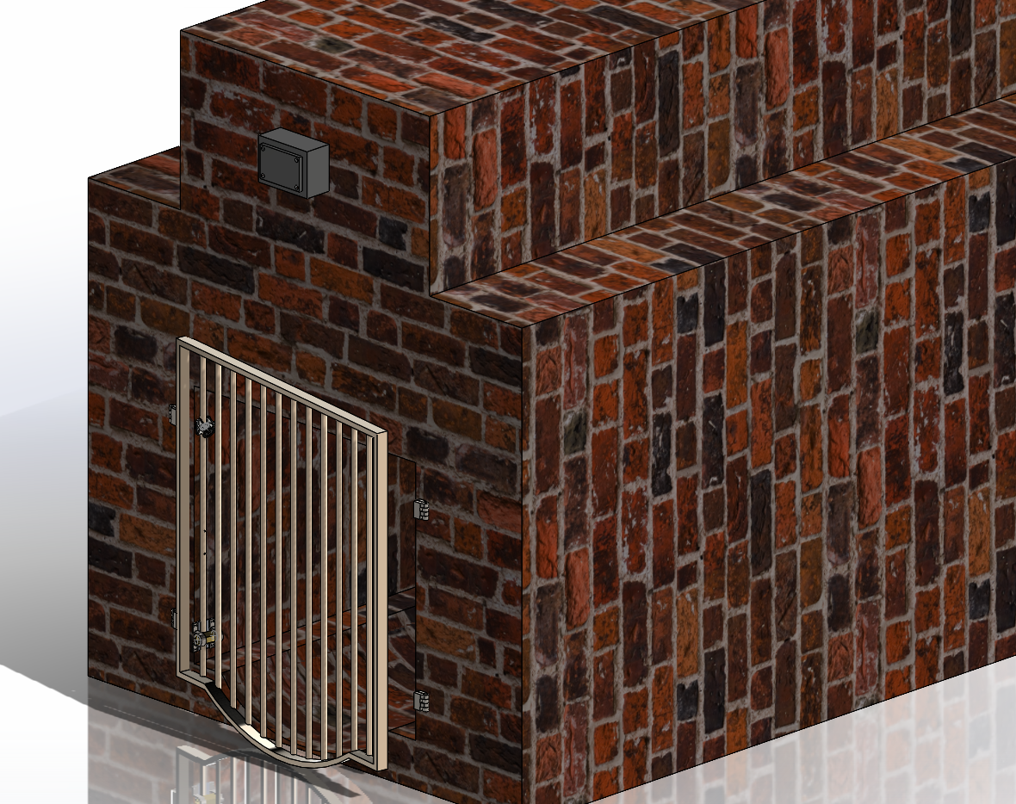

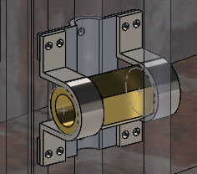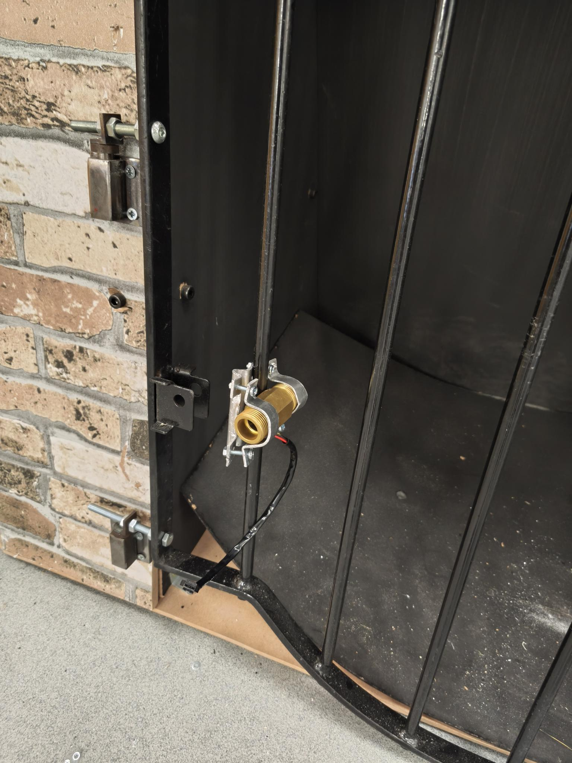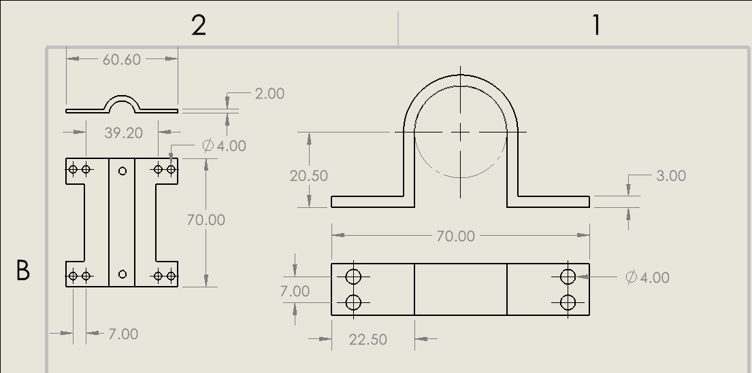
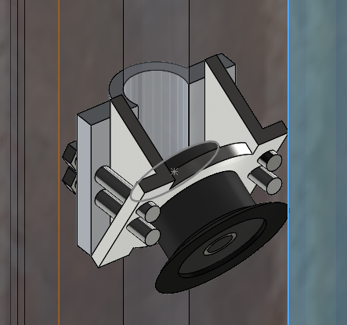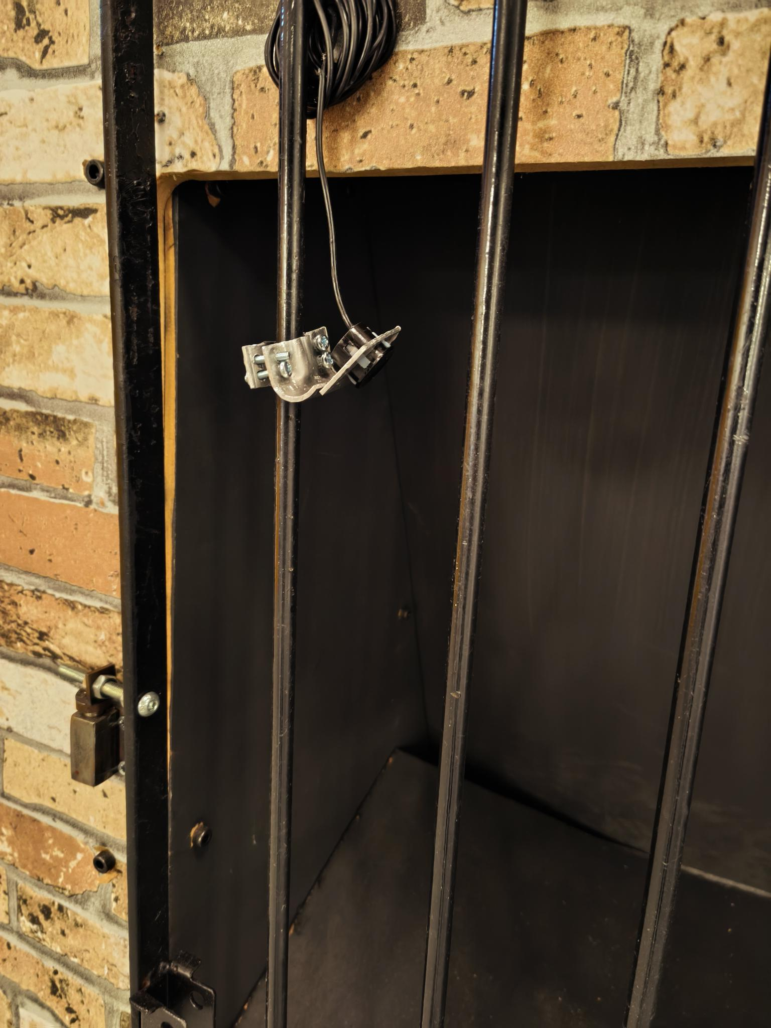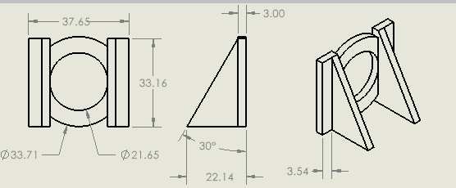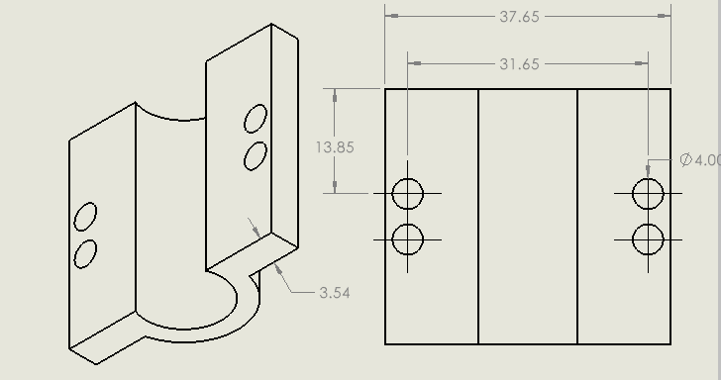

Test Results
Sensor accuracy was validated over 5 trials at a fixed 50 cm distance under controlled indoor conditions:
Trial | Sensor A (cm) Sensor B (cm) Flow (L/min)
1 | 49.9 50.0 280.0
2 | 50.1 50.0 284.0
3 | 50.0 49.9 284.0
4 | 50.1 49.9 292.0
5 | 50.0 50.1 284.0

Both ultrasonic sensors demonstrated accuracy to the nearest 1 cm across all trials, with maximum deviation of ±0.1 cm. Flow readings were consistent at the tap’s fixed rate. The alert logic was triggered correctly in simulated blockage conditions.

Reflection
- First experience writing functional embedded code for a real-world sensor system
- Learned importance of voltage-level compatibility between components (5V vs 3.3V)
- Stakeholder analysis shaped every design decision — cost dominated over performance
- Modular code variables section was a team-driven decision that proved valuable for calibration
- Recommended future improvement: replace Pico with ESP32 for built-in Wi-Fi and direct email alerting

PROJECT 03
Portable Lifting Mechanism
Mechanical Design • SolidWorks • 3D Printing • Mechanical Advantage

Project Overview
Designed and built a small-scale prototype of a portable, human-powered lifting mechanism for construction use. Commissioned by Speller-Metcalfe, the full-scale system is intended to lift a 450 kg steel beam to 4 metres at Hereford’s new Community Diagnostics Centre — fitting through a standard doorway (1150×2200 mm) and powered entirely by mechanical advantage.
A 1:13.3 scale model was constructed to prove the concept, targeting a lift of 2 kg to 300 mm height. The project involved mechanical calculations, SolidWorks CAD, 3D printing, laser-cut acrylic fabrication, and physical testing.

Client | Speller-Metcalfe (construction contractor)
Full-scale target | 450 kg lifted to 4 metres through a 1150×2200 mm doorway
Scale model target | 2 kg lifted to 300 mm; model height < 1 metre
Drive system | Dual lead screws + bevel gear system
Materials | 6 mm acrylic frame, 3D-printed ABS gears, aluminium crank shaft
Team size | 3 students

Design Process

Concepts Evaluated
Three mechanisms were explored before arriving at the final design:
- Scissor lift: high vertical travel and stability, but too wide for the doorway and structurally weak at height
- Rack and pinion: good range of motion but required a fixed 4-metre column — impractical for portability
- Dual lead screw with bevel gears: modular, portable, and capable of achieving the required mechanical advantage through combined gear and screw systems
A weighted decision matrix quantified each option against portability, safety, mechanical advantage, ease of use, and cost. The dual lead screw design scored highest.

Mechanical Advantage Calculations
Two separate mechanical advantage systems were combined:
- Gear system: two 1:2 ratio bevel gears (15 teeth : 30 teeth) producing 4× MA
- Lead screws: circumference = 66 mm, pitch = 22 mm → MA = 66/22 = 3 per screw
- Two screws combined: 3 × 2 = 6 MA from screws
- Total mechanical advantage: 6 (screws) × 4 (gears) = 24 MA
- Effective operator load: 450 kg ÷ 24 = 18.75 kg equivalent force
- With 30 cm crank handle and 11.25 cm gear radius: additional 2.6× advantage → real operator effort = 7.2 kg
- Turns to full height: 4000 mm ÷ 22 mm pitch × 4 (gear ratio) = 727 crank rotations

Small-Scale Model Construction
The scale model was designed in SolidWorks and broken down into laser-cuttable 2D parts:
- Frame: 6 mm acrylic sheet, mortice-and-tenon inspired joints bonded with 2-part epoxy
- Gears: 3D-printed ABS plastic (small gear: 15 teeth, 22.5 mm dia; large gear/pinion: 30 teeth, 45 mm dia)
- Crank shaft: 104 mm aluminium bar, machined on the lathe with 11 mm shaft holes
- Assembly: super-glue for gear-to-shaft joints; 2-part epoxy for frame perpendicular joints
- Trusses: 8 trusses (base 104 mm, height 26 mm) placed 6 mm from each corner

CAD Models & Photos
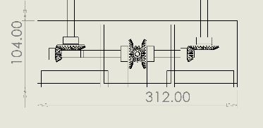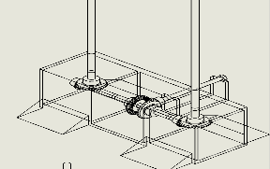

Results
The model demonstrated proof of concept but did not meet the full specification. It successfully lifted 2 kg to 10 cm before the acrylic roof structure and 3D-printed gear assembly collapsed under combined compressive and bending loads.
- Gear misalignment caused uneven tooth loading — ABS plastic deformed under stress
- 2-part epoxy joints failed under peeling forces at the roof connection (effective for shear, not peel)
- Lead screw and gear MA calculations were verified correct — structural failure was the limiting factor
- Full torque and speed testing was not completed due to model failure

Recommendations for Improvement
Gear quality | Use off-the-shelf metal gears rather than 3D-printed ABS — more precise mesh and higher load capacity
Gear shaft | Cross shaft through the full width of the structure to keep gears concentric and reduce lateral flex
Adhesive | Replace 2-part epoxy with bolted joints or structural adhesive rated for peel forces
Screw material | Use stainless or hardened steel lead screws — resist thread stripping under 450 kg compressive load
Modular connection | Increase thread engagement length at modular screw joint to resist bending moment at connection

Reflection
- First experience designing a functional mechanism from first principles using mechanical advantage calculations
- Gained hands-on experience with lathe, pillar drill, band saw, laser cutter, and 3D printer
- SolidWorks skills developed significantly — produced full assembly, 2D part drawings, and gear models
- Failure taught more than success — structural analysis of why it failed was methodical and valuable
- Belbin role (Co-ordinator): managed team expectations, delegated tasks, and contributed all mechanical advantage calculations and feasibility analysis

Jack Weir • MEng Engineering, NMITE • Jack.harold.weir@gmail.com • 07398 813066

